Supplementary material
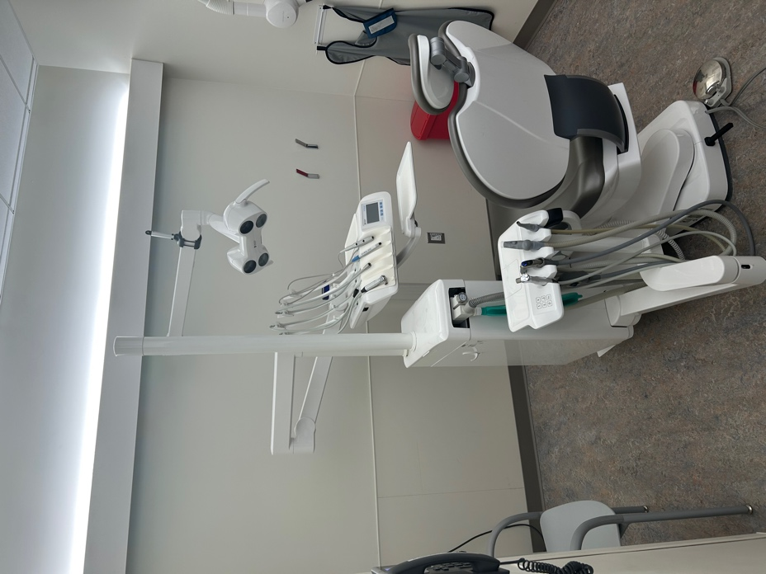
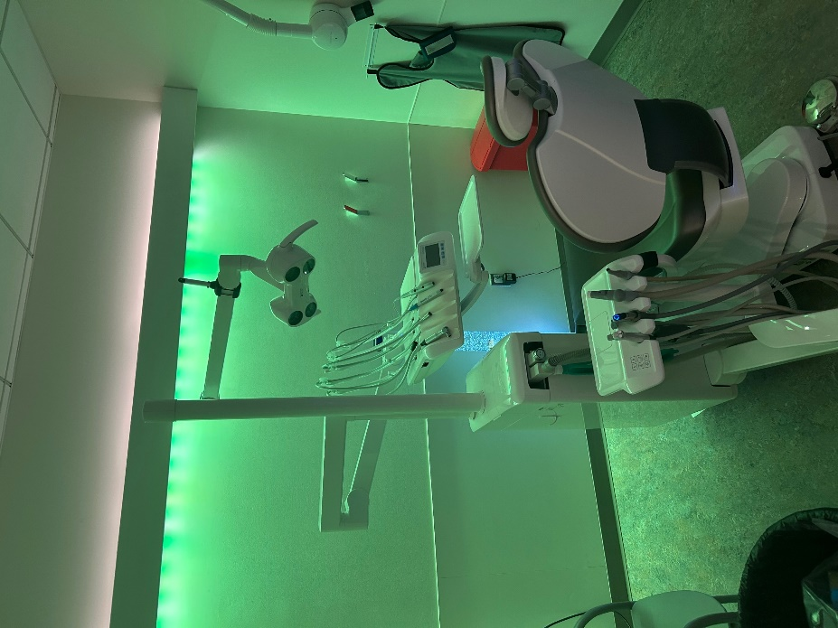
A.
B.
Supplementary Fig. 1. Control versus treatment conditions. (A) shows the control (standard white light-exposed operatory) and (B) shows the treatment (green light-exposed operatory) settings in which all participants received a dental prophylaxis three months apart.

Supplementary Table 1. Mean values for heart rate and concentration of salivary cortisol and alpha amylase in all participants at the beginning (i.e., pre- dental prophylaxis) and end (i.e., post- dental prophylaxis) of each visit.
 | Control |  | Treatment |  | Mean difference |  | p-value²
 | Pre¹ | Post¹ | Post¹ | Post¹ | Control | Treatment | Treatment | Time | Interaction
Heart rate (BPM) | 94.2 (14.5) | 89.3 (18.5) | 92.5 (17.5) | 96.0 (16.9) | −4.8 (22.3) | 3.5 (20.4) | 0.4132 | 0.8847 | 0.3461
Salivary cortisol (ng/mL) | 2.6 (1.8) | 3.0 (2.2) | 2.8 (2.4) | 3.3 (2.7) | 0.4 (1.0) | 0.5 (2.2) | 0.6667 | 0.2010 | 0.8897
Salivary AMY1 (µg/mL) | 4.1 (1.5) | 4.8 (2.7) | 4.5 (1.9) | 5.4 (2.3) | 0.7 (2.2) | 0.9 (2.4) | 0.1914 | 0.2053 | 0.7793
¹Mean (SD).
²Two-way repeated measures ANOVA, treatment × time.

Supplementary Table 2. Median values for behavior, anxiety, and pain scores assessed in all participants in both the control (i.e., white light-exposed dental operatory) and treatment (i.e., green light-exposed dental operatory) conditions.
 | Control  N = 12¹ | Treatment  N = 12¹ | Difference¹ | p-value²
Frankl behavior rating scale | 2.5  (1.9, 2.8) | 3.0  (2.2, 3.4) | 1  (0.0, 1.0) | 0.1797
Venham behavior rating scale | 1.0  (0.9, 2.8) | 1.0  (0.5, 2.2) | 0  (−0.9, −0.07) | 0.0625
Venham anxiety rating scale | 2.0  (0.8, 2.7) | 1.0  (0.6, 2.1) | −1  (−1.4, 0.5) | 0.3066
Revised-face, legs, activity, cry, consolability scale | 0.60  (0.3,1.0) | 0.30  (0.1,0.8) | −0.3  (−0.5, 0.07) | 0.1650
Faces pain scale-revised | 0.0  (−0.3, 2.3) | 0.0  (−0.2, 0.5) | 0  (−2.1, 0.4) | 0.5000
¹Median (95% confidence interval).
² Wilcoxon matched-pairs signed rank test.

